|  |  |
| --- | --- |
| **Name:** | Rishav Dugar |
| **Roll Number:** | 19IM3FP30 |

1. **Aim of the experiment** a) Familiarisation with Resistor, Capacitor and Inductor

b) Understanding Ohm’s Law

1. **Tools used:** Resistors, voltage source , connecting wires , voltmeter , ammeter , diode
2. **Background knowledge (brief):**

A **resistor** is a [passive](https://en.wikipedia.org/wiki/Passivity_(engineering)) [two-terminal](https://en.wikipedia.org/wiki/Terminal_(electronics)) [electrical component](https://en.wikipedia.org/wiki/Electronic_component) that implements [electrical resistance](https://en.wikipedia.org/wiki/Electrical_resistance) as a circuit element. It offers hindrance to the flow of electrons. It is measured in ohms where 1 ohm is the resistance offered when 1 A current flows across a potential difference of 1 V.

In series R = R1 + R2 (current flow is same)

In parallel 1/R = 1/R1 + 1/R2 (potential difference is same) 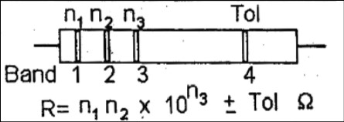

A **capacitor** is a device that stores [electrical energy](https://en.wikipedia.org/wiki/Electrical_energy) in an [electric field](https://en.wikipedia.org/wiki/Electric_field). The effect of a capacitor is known as [capacitance](https://en.wikipedia.org/wiki/Capacitance). An ideal capacitor is characterized by a constant [capacitance](https://en.wikipedia.org/wiki/Capacitance) *C*, in [farads](https://en.wikipedia.org/wiki/Farad) in the [SI](https://en.wikipedia.org/wiki/SI) system of units, defined as the ratio of the positive or negative charge *Q* on each conductor to the voltage *V* between them. A capacitance of one [farad](https://en.wikipedia.org/wiki/Farad) (F) means that one [coulomb](https://en.wikipedia.org/wiki/Coulomb) of charge on each conductor causes a voltage of one [volt](https://en.wikipedia.org/wiki/Volt) across the device. It resists potential change across it.

An inductor, also called a coil, choke, or reactor, is a [passive](https://en.wikipedia.org/wiki/Incremental_passivity) [two-terminal](https://en.wikipedia.org/wiki/Terminal_(electronics)) [electrical component](https://en.wikipedia.org/wiki/Electronic_component) that stores energy in a [magnetic field](https://en.wikipedia.org/wiki/Magnetic_field) when [electric current](https://en.wikipedia.org/wiki/Electric_current) flows through it.It resists the change of current flowing through it and is in compliance to Lenz’s Law. An inductor is characterized by its [inductance](https://en.wikipedia.org/wiki/Inductance), which is the ratio of the voltage to the rate of change of current. 1 henry(H) is self-inductance of that coil in which 1V emf is produced when the rate of change of current in that coil is 1 A/s.

Each of these components serve various roles in the electronics and are available in different types. Their values are usually colour-coded on them.

Ohm’s law states that the current through a conductor between two points is directly proportional to the voltage across the two points. Such a conductor is characterized by its ‘Resistance’ – R measured in Ohms. The devices which follow Ohm’s law are called Ohmic devices like resistors while those that don’t follow are called Non-ohmic devices like diodes, transistors etc.

1. **Circuit (hand drawn/image)**

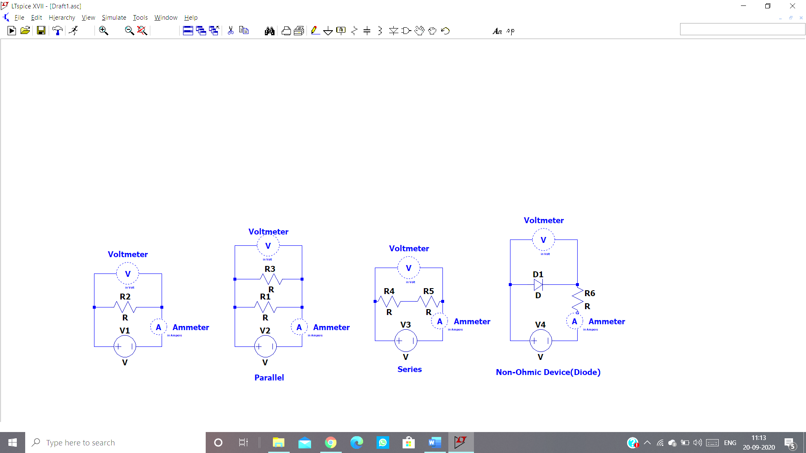

**in mA**

**in mA**

**in mA**

**in mA**

1. **Measurement Data (Tabular form)**

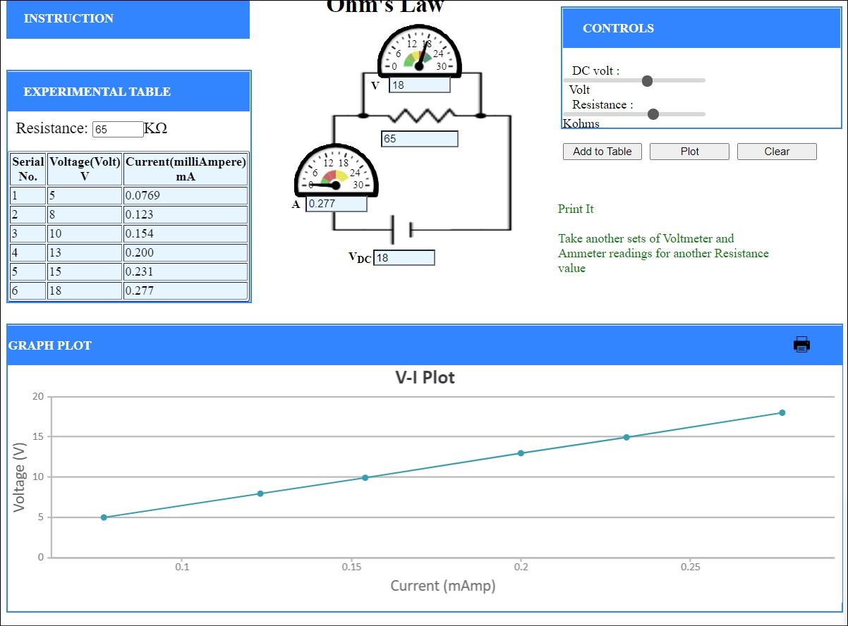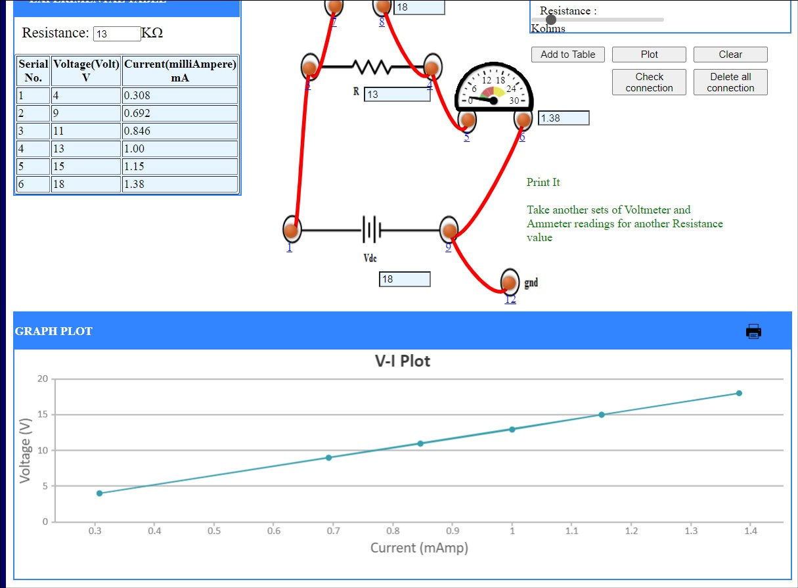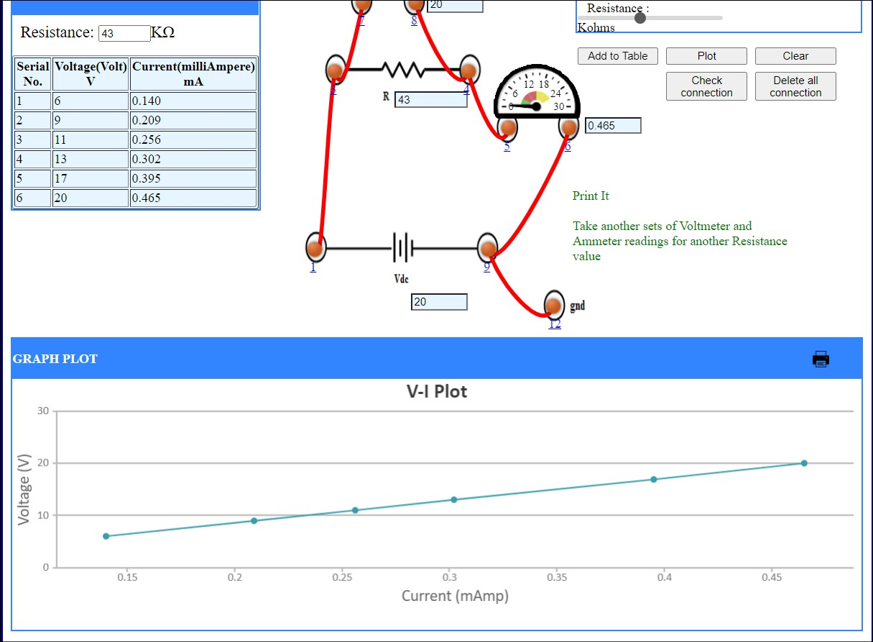

For series

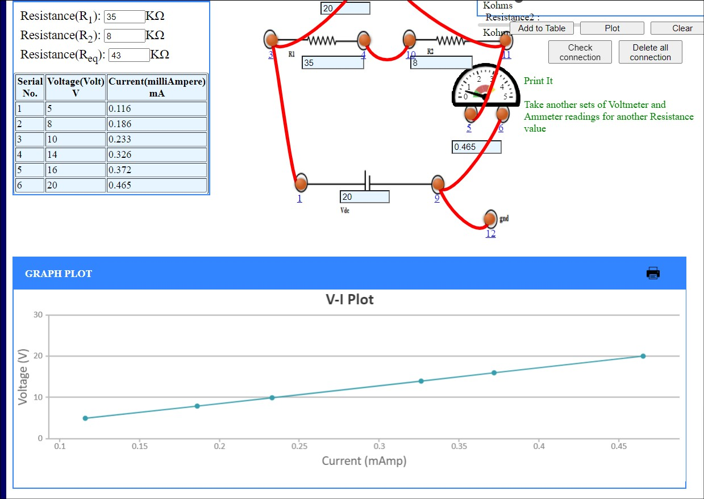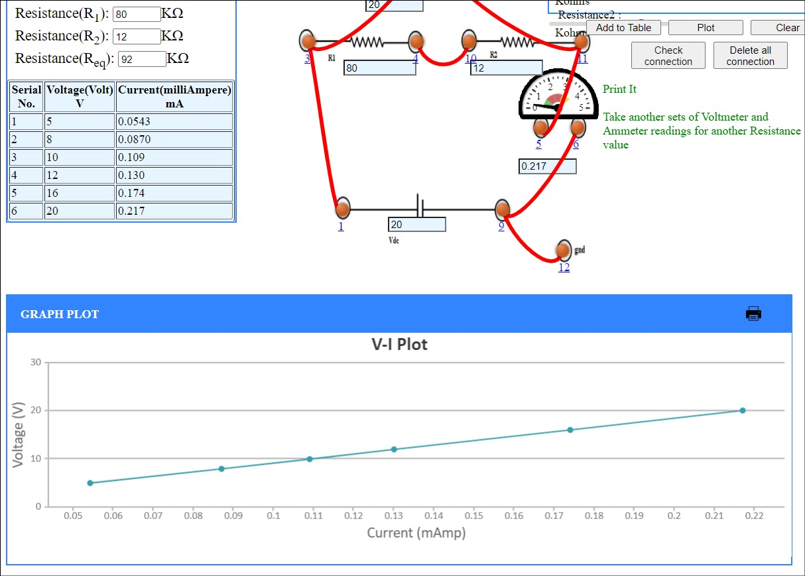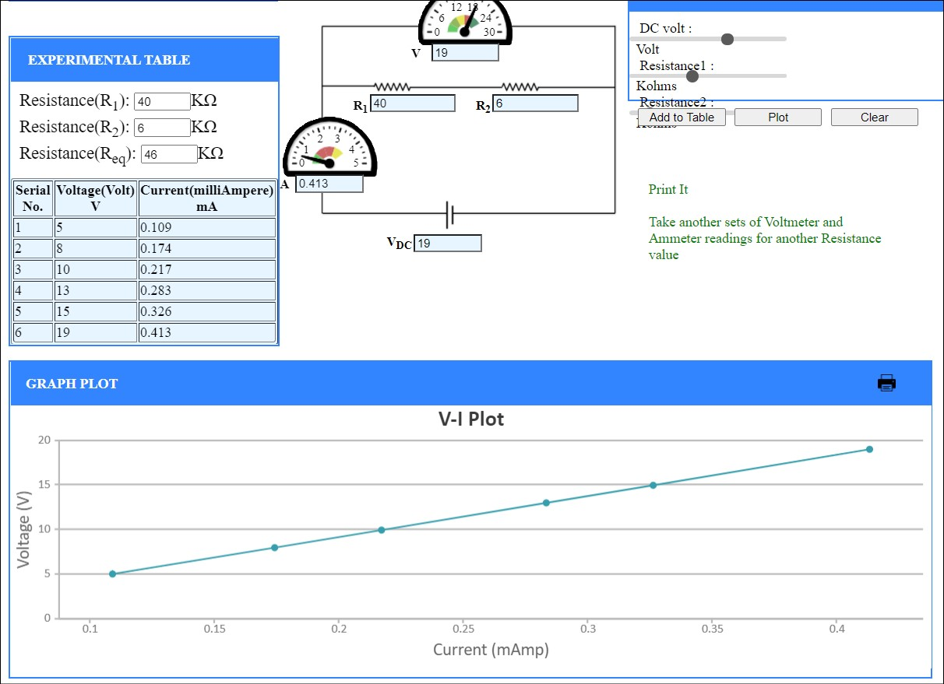

For parallel

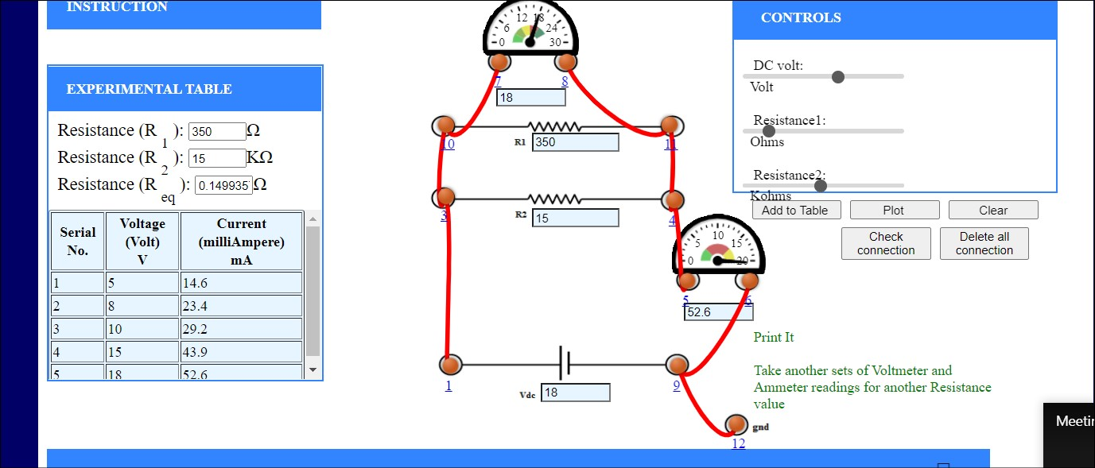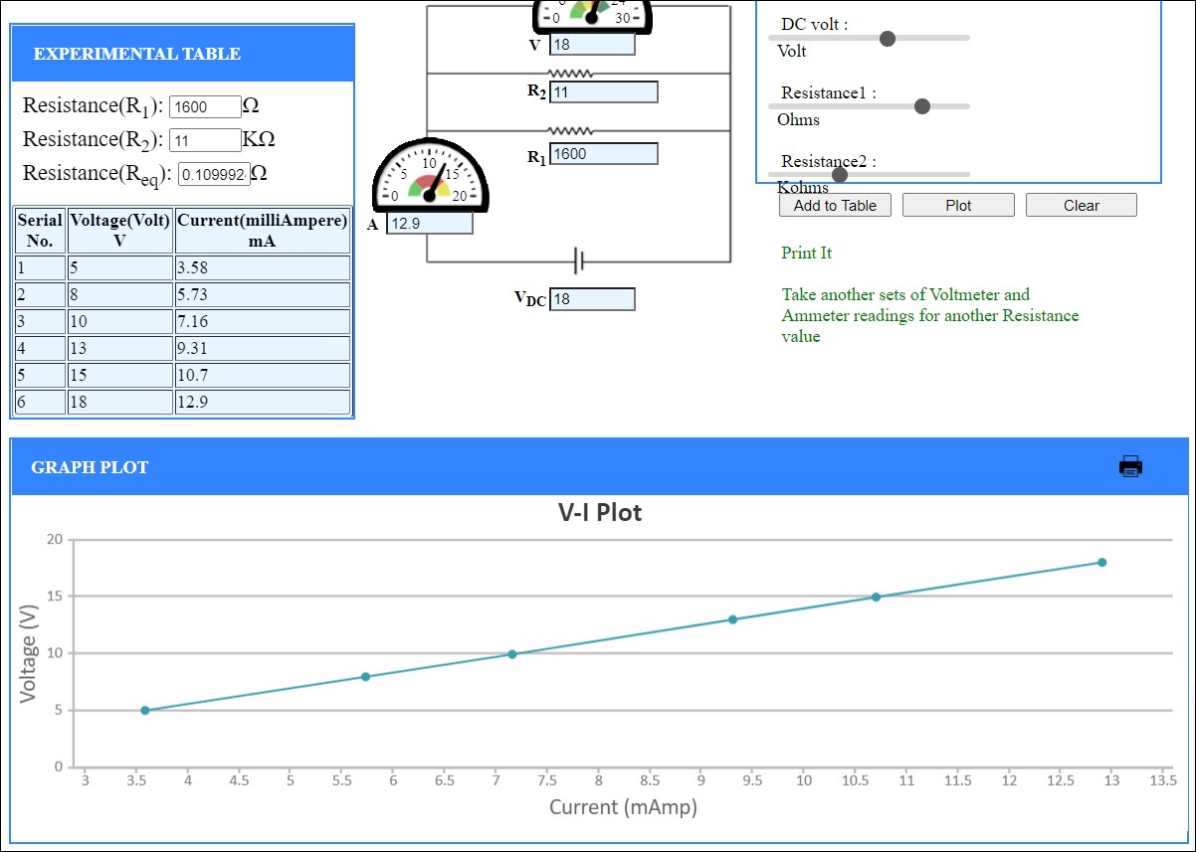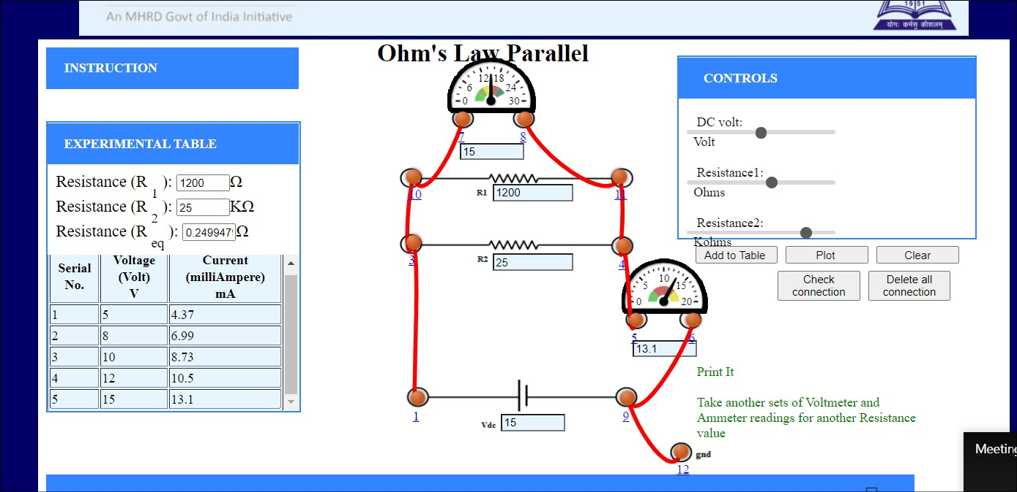

For Non-Ohmic

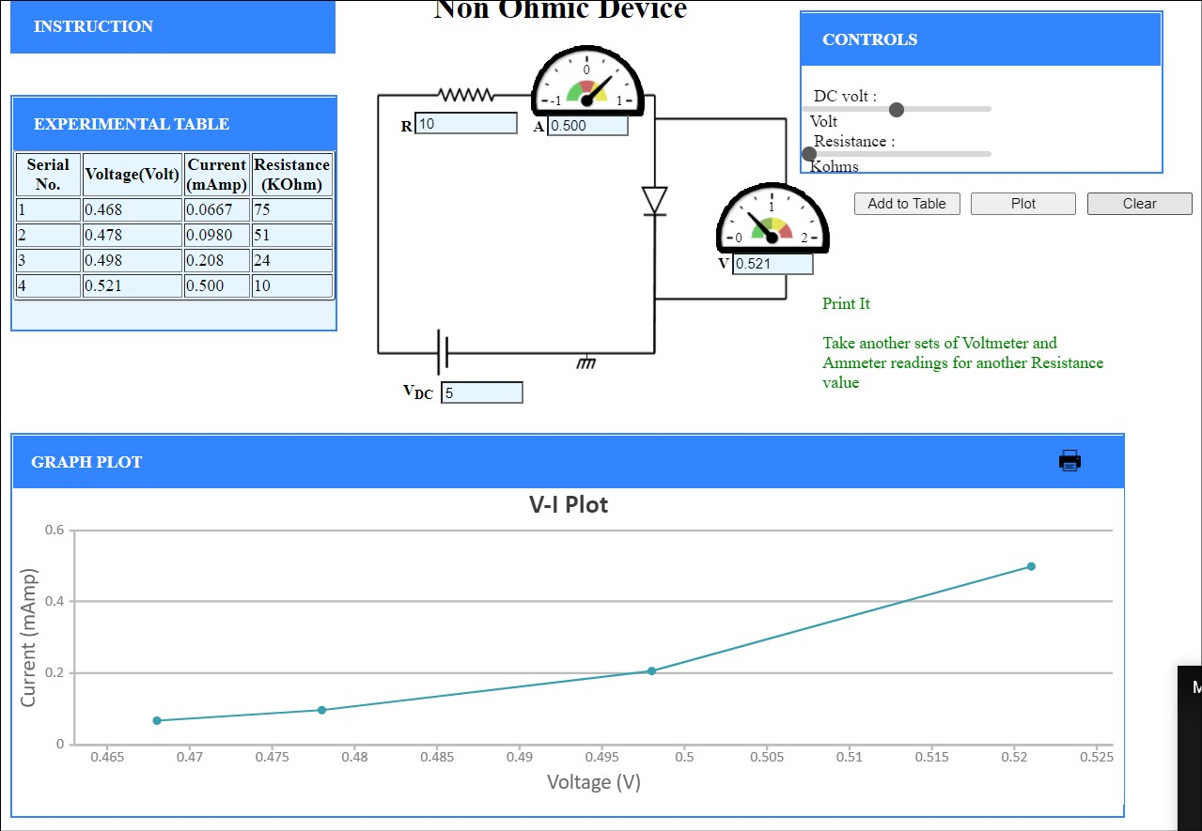

1. **Graph (Image)/Screenshots**

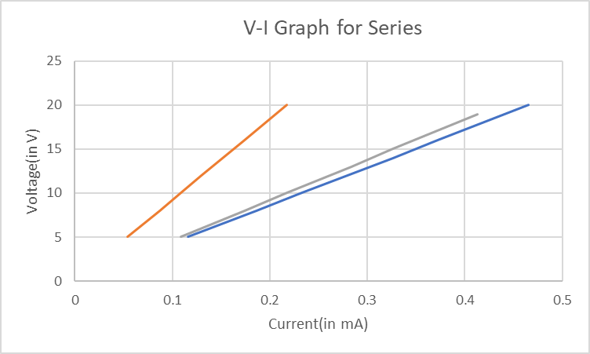

1. **Conclusion**

Ohm’s law is followed by resistors in series and parallel connections too.

Diodes are non-ohmic elements as is evident from their V-I characteristics.

1. **Discussions**

Resistors, capacitors and inductors are some of the basic passive elements of the circuit. Capacitors and inductors can be used as energy storing elements through electric field and magnetic field respectively.

Non-ohmic components have resistance that is a function of external and internal factors like current, temperature etc.